Hierarchical Clustering
Code:
import matplotlib.pyplot as plt
import seaborn as sns
import numpy as np
import pandas as pd

from sklearn.datasets import load_breast_cancer
from sklearn.preprocessing import StandardScaler
from sklearn.decomposition import PCA
from scipy.cluster.hierarchy import dendrogram, linkage, fcluster

cancer = load_breast_cancer()

X = cancer.data
labels_true = cancer.target
feature_names = cancer.feature_names

scaler = StandardScaler()
X_scaled = scaler.fit_transform(X)

pca = PCA(n_components=2)
X_pca = pca.fit_transform(X_scaled)

linkage_methods = ['single', 'complete', 'average', 'ward']

plt.figure(figsize=(15, 12))

for i, method in enumerate(linkage_methods, 1):
plt.subplot(2, 2, i)

Z = linkage(X_scaled, method=method)

dendrogram(Z, truncate_mode='level', p=5)

plt.title(f'Hierarchical Clustering - {method.capitalize()} Linkage')
plt.xlabel('Sample Index')
plt.ylabel('Distance')

plt.tight_layout()
plt.show()
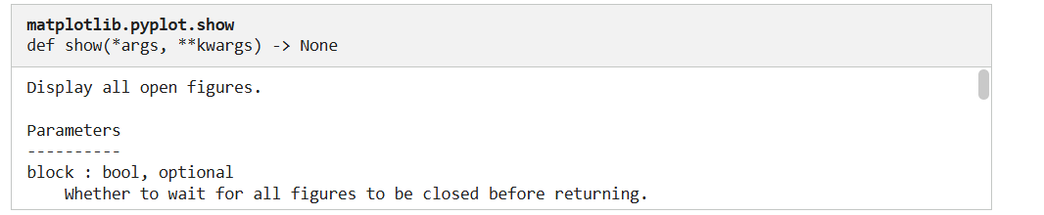
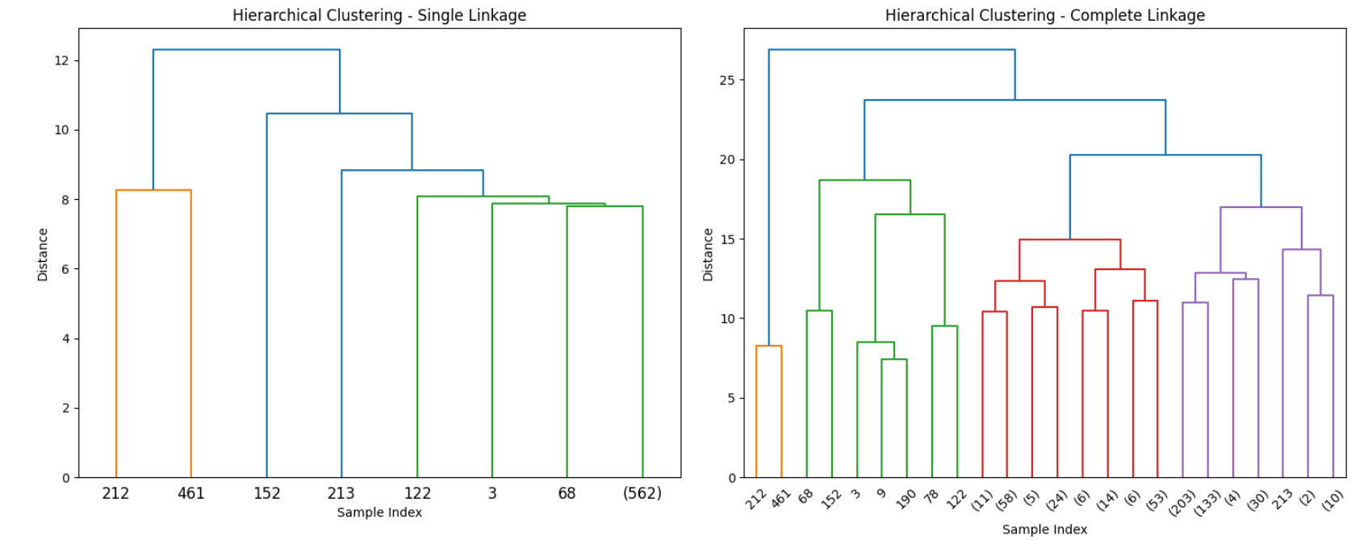
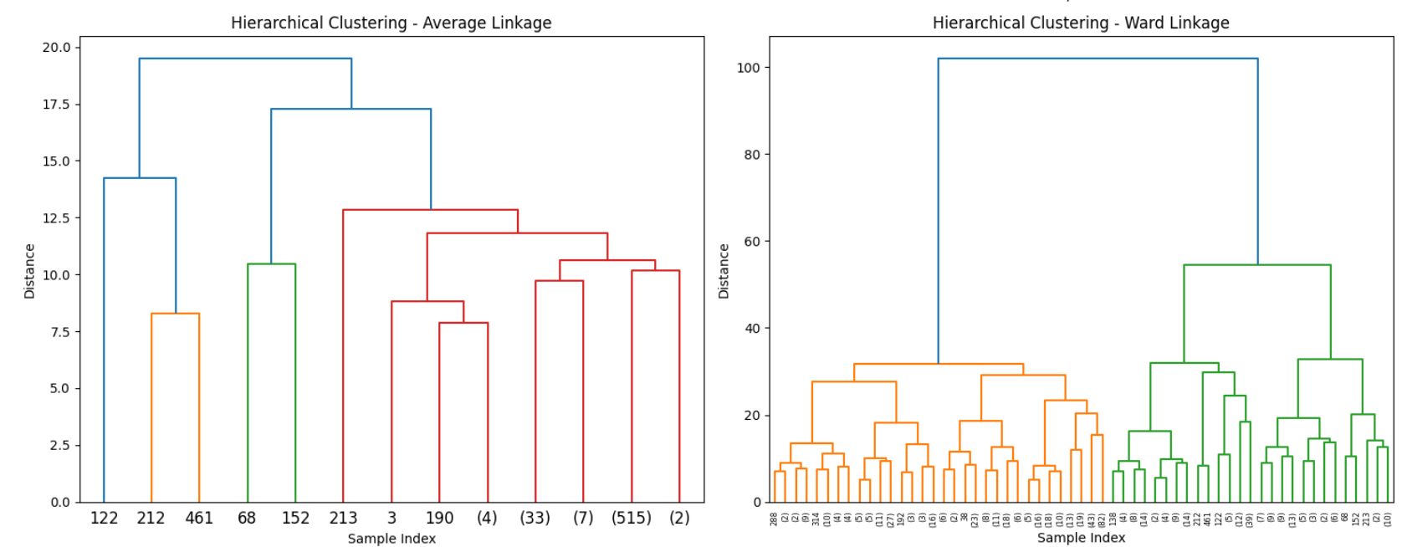

for method in linkage_methods:
Z = linkage(X_scaled, method=method)

clusters = fcluster(Z, t=2, criterion='maxclust')

print(f"\nCluster assignments using {method} Linkage:")
print(pd.Series(clusters).value_counts())
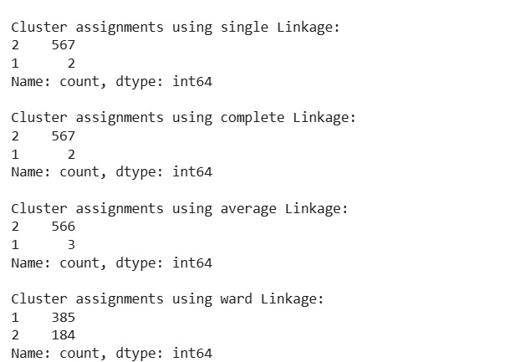

plt.figure(figsize=(6, 5))
sns.scatterplot(
x=X_pca[:, 0],
y=X_pca[:, 1],
hue=clusters,
palette="Set1",
s=60
)
plt.title(f"Scatter Plot (PCA reduced - {method.capitalize()} Linkage)")
plt.xlabel('PCA Component 1')
plt.ylabel('PCA Component 2')
plt.show()

Output:
